**Agile Accelerator:**

It is Salesforce’s answer to follow and manage Agile product development from the organization’s Salesforce org (available for download from the salesforce AppExchange). It is used to track issues, bugs, user stories.

It is secure and fully integrated with other Salesforce Apps. It runs on the Salesforce1 platform, so the team gets to go mobile and social (courtesy Salesforce1 mobile app).

Common terms in Agile Accelerator:

**Team**: Agile teams include cross-functional teams. One of the first steps in Agile Development is defining your team

**Product tags**: useful when categorizing work items. They are unique for each team; at least one tag per team. Usually represent product areas or departments, but depends on the organization’s decision

For example, let’s say you have a small team that produces an application called Find Files. You can create a product tag called FindFiles and use it with all work items. But, what if the team is larger and produces your Find Files application for Android and iOS users? Half the team members work on iOS and the other half work on Android. You can then create two product tags called FindFiles-iOS and FindFiles-Android and use the two tags to separate the work for each group within the team.

**Sprint:** a specific, set time period wherein a set amount of work is to be completed and ready for review: the work may be a number of user stories; this is usually done to break down work to manageable chunks

**Epics:** These are high-level user stories, that are usually broken down to smaller user-stories, that are worked on in sprints. An Epic may be worked on in many sprints

As an example, let’s use making a movie. The entire movie is the Epic, and each scene in the movie is a User Story. If you don’t break the movie into smaller parts, like scenes, it’s challenging to scope and manage things such as budget, actors, and filming time. Some other examples of potential Epics where it's necessary to break the project into smaller parts to judge the scope of the work are:

• Creating a mobile application that tracks mobile visitors to your website for both iOS and Android

• Creating a way to add users to Salesforce in bulk

• Training users how to use a new software release

**Themes:** Are used to group similar user stories that may be focusing on a common system or feature

As you split an Epic into smaller User Stories, you can use themes to group similar User Stories together. For example, when creating a mobile application for visitor tracking, organize your User Stories with an iOS theme and an Android theme

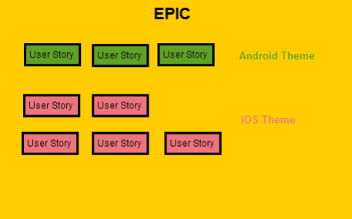

**Work-item:** A collection of tasks, that make up a sprint (can be a user-story, bug or investigation)

**Task:** Within each user story, you can create tasks that are assigned to individual team members. That way, you can keep a detailed record of the progress for each story. Whenever we create a user story, we can create a task and assign to individual team members. It helps to track the progress for each story, especially when more than one person is working on a user story.

**Backlog Manager:** The Backlog Manager is a great place to go when you need to manage all of your team’s work. The Backlog Manager gives better visibility of a team’s work to other teams who might want to see if there are potential dependencies. This provides better visibility across the organization.

The Agile Accelerator provides both Scrum and Kanban boards (the Kanban board is customizable).

The following are the additional features of Agile Accelerator

Custom picklist values for work record

* We can customize the picklist values of “Status” field on work records.

Note:  Don’t remove the “Closed” value as it will affect Sprint Velocity calculation.

Custom fields for work records

* We can also modify or add fields in Additional Field section on the work records.

Custom fields for Product tags

* We can modify or add fields to product tags that are unique to specific team or product tag.
* If the field is required for a few Product tags, then add it in “product tag” level.
* If the field is required for the entire org, then add it in “Work Object” level.

Configure Communities

* We can use the Agile Accelerator with Communities to create work items.
* We must contact Salesforce for provide information about adding Communities license to your Organization.

Configure Email Volume

* The user can choose which type of Email notification the user can receive when work record changes. The following are notification levels
* Bread & Butter – This notification will send if the user added as an Assignee and other users added Comments.
* Meat & Potatoes – This notification will cover everything additionally if any changes in the status field of work item in the default level.
* The Whole Enchilada – This notification includes everything in Meat & Potatoes, and any additional changes

Link to Salesforce Agile Accelerator starter manual: <https://appexchange.salesforce.com/servlet/servlet.FileDownload?file=00P3A00000RrREfUAN>

**Agile Accelerator Hands-on:**

**Create New Team**

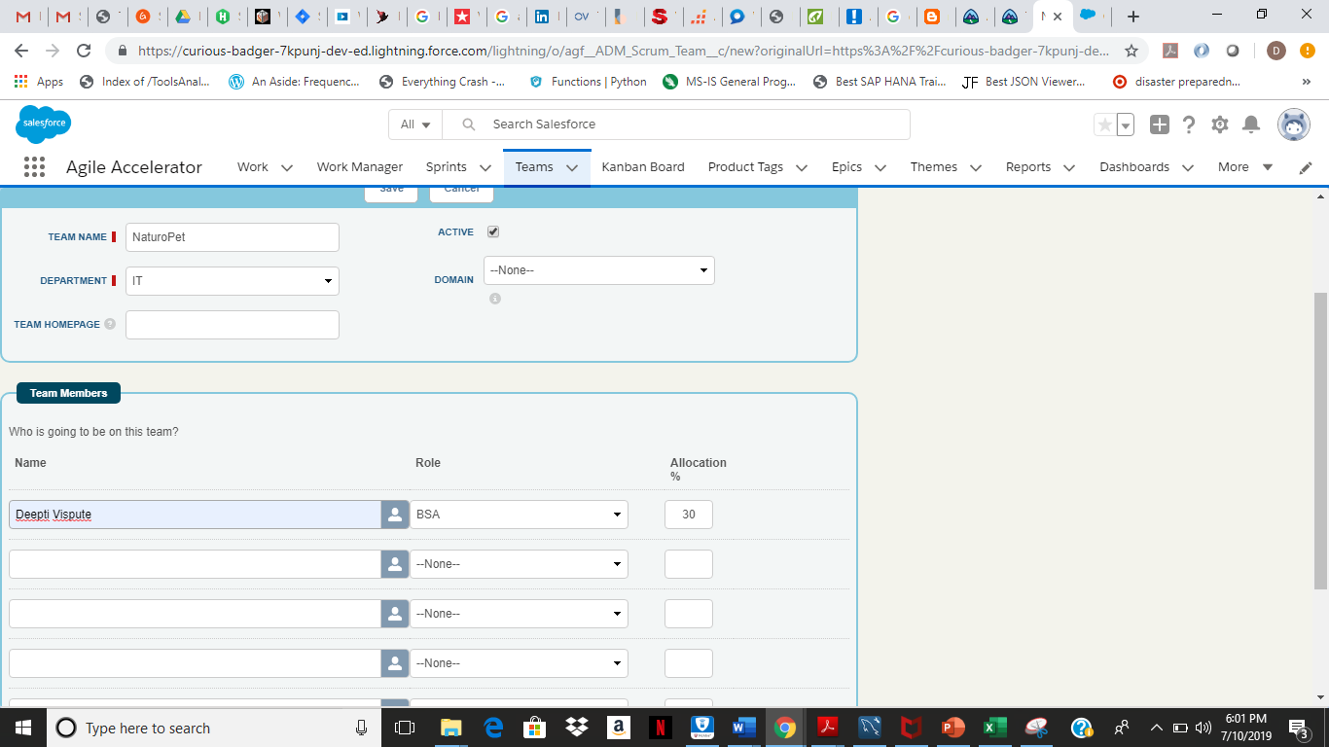

**Creating Epic:**

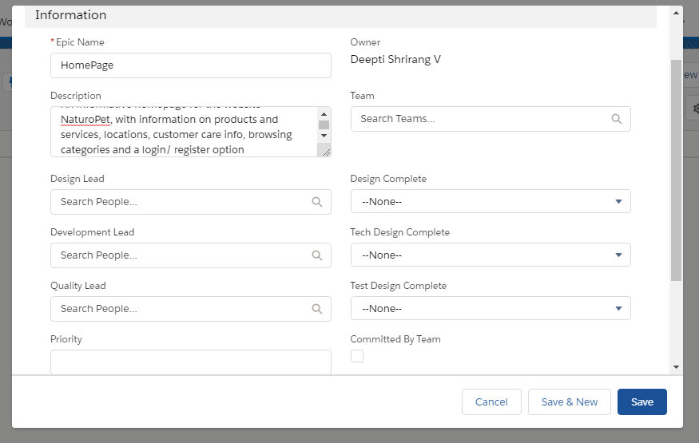

**Task creation:**

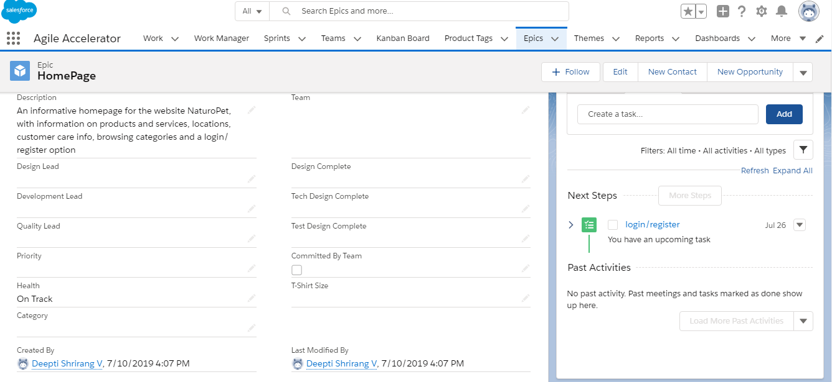

**Creating a theme**

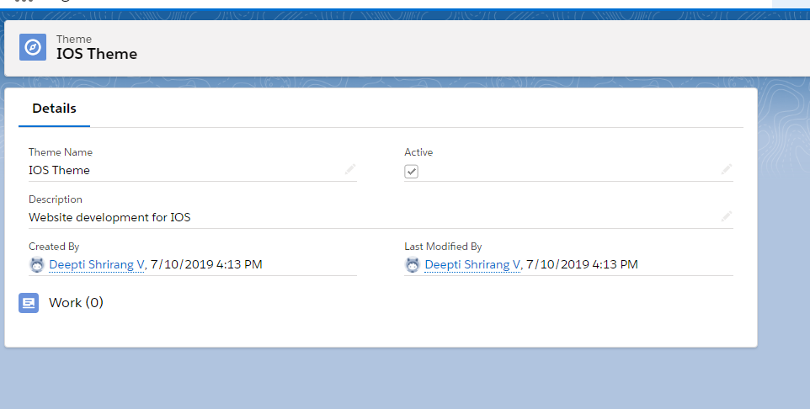

**Work: User story:**

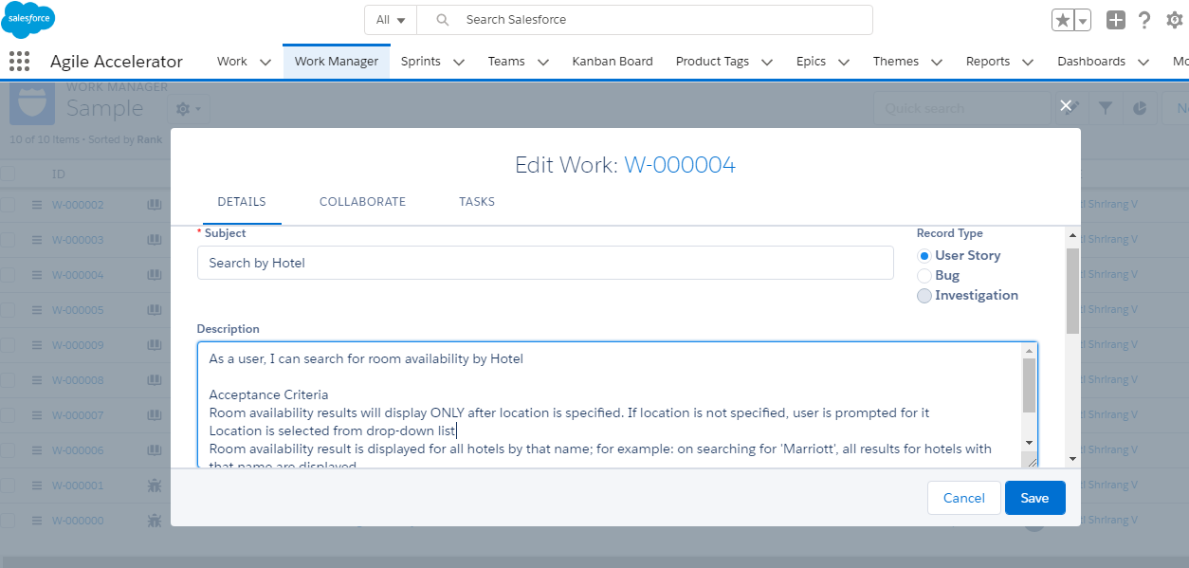

Please Note: Further work on Agile Accelerator will be submitted in subsequent days